**H5 file link:**

https://drive.google.com/file/d/1Yratzq8Rg7Rra6yR2tld42jd6SeOORS8/view?usp=sharing

**Approach Summary:**

|  |  |  |  |  |
| --- | --- | --- | --- | --- |
| **Exp.No.** | **Model** | **No. Of Trainable**  **Parameters** | **Result/Accuracy** | **Comment** |
| 1. | **Conv3D**   * **Batch_size=64** * **Activation function = ‘relu’** * **Kernel_size=(3,3,3)** * **Using last 18 image frames** | 8,958,629 | categorical_accuracy: 0.1897  val_categorical_accuracy: 0.2083 | **Model under-fitting.** |
| **2.** | **Conv3D**   * **Batch_size=64** * **Activation function = ‘elu’** * **Kernel_size=(3,3,3)** * **Using last 18 image frames** * **Using last 18 image frames** | 8,958,629 | categorical_accuracy: 0.1700 val_categorical_accuracy: 0.1806 | **Model is under-fitting. Changing the activation function did not improve accuracy,** |
| **3** | **Conv3D**   * **Batch_size=64** * **Activation function = ‘relu’** * **Kernel_size=(2,2,2)** * **Using last 18 image frames** | 9,856,901 | categorical_accuracy: 0.2016 val_categorical_accuracy: 0.1806 | **Model Under-fitting.**  **Changing the kernel size did not improve accuracy,** |
| **4.** | **Conv3D**   * **Batch_size=64** * **Activation function = ‘relu’** * **Kernel_size=(2,2,2)** * **Using last 18 image frames** | 9,856,901 | **Got ResourceExhaustedError. This means we cannot experiment with batch sizes larger than 64.** | **This means we cannot experiment with batch sizes larger than 64.** |
|  |  |  |  |  |
| **Exp.No.** | **Model** | **No. Of Trainable**  **Parameters** | **Result/Accuracy** | **Comment** |
| **5.** | **Conv3D**   * **Batch_size=64** * **Activation function = ‘elu’** * **Kernel_size=(3,3,3)** * **Using alternate frames** | 9,439,365 | categorical_accuracy: 0.5692 val_categorical_accuracy: 0.6667 | **Model Over-fitting.**  **Using alternate frames improved model performance.** |
| **6.** | **Conv3D**   * **Using (84X84) image frames** * **Updated momentum 0.7 to 0.9 in SGD optimizer** | 9,439,365 | categorical_accuracy: 0.7668 val_categorical_accuracy: 0.7639 | **No over-fitting or under-fitting.**  **Updating momentum reduced the difference between train and validation accuracy.** |
| **7.** | **Conv3D**   * **Using (100X100) image frames** | 12,322,949 | categorical_accuracy: 0.7708 val_categorical_accuracy: 0.7361 | **No over-fitting or under-fitting.**  **Changing image size did not improve accuracy.** |
| **8.** | **Conv3D**   * **Using (100X100) image frames** * **Learning Rate starting from 0.0001** | 12,322,949 | categorical_accuracy: 0.5850 val_categorical_accuracy: 0.6389 | **Slight over-fitting.** |
| **Exp.No.** | **Model** | **No. Of Trainable**  **Parameters** | **Result/Accuracy** | **Comment** |
| **9.** | **Conv3D**  **-Using (84X84) images**  **- Using all 30 frames.** | 9,439,365 | categorical_accuracy: 0.8024 val_categorical_accuracy: 0.6944 | **Slightly over-fitting.** |
| **10.** | **Conv2D + GRU**   * **Using last 18 (84X84) images per video** * **Using momentum as 0.7 in SGD optimizer** | 1,274,245 | categorical_accuracy: 0.1897 val_categorical_accuracy: 0.2083 | **Under-fitting.** |
| **11.** | **Conv2D + GRU**   * **Adding more layers** * **Using last 18 (84X84) images per video** * **Using momentum as 0.7 in SGD optimizer** | 733,957 | categorical_accuracy: 0.1897 val_categorical_accuracy: 0.2083 | **Under-fitting.** |
| **12.** | **Conv2D + GRU**   * **Using 18 last (100X100) images** * **Using momentum as 0.7 in SGD optimizer** | 1,004,293 | categorical_accuracy: 0.1897 val_categorical_accuracy: 0.2083 | **Under-fitting.** |
| **13.** | **Conv2D + GRU**   * **Using alternative 18 (84X84) images** * **Updating momentum as 0.9** | 733,957 | categorical_accuracy: 0.7984 val_categorical_accuracy: 0.7083 | **Slightly over-fitting. Using alternative frames improved accuracy.** |
| **Exp.No.** | **Model** | **No. Of Trainable parameters** | **Result/Accuracy** | **Comment** |
| **14.** | **Conv2D + GRU**   * **Using 18 alternative (100X100) images** * **Using momentum as 0.9** | 1,004,293 | categorical_accuracy: 0.8696 val_categorical_accuracy: 0.6389 | **Over-fitting increased after increasing frame size.** |
| **15.** | **Conv2D + GRU**   * **Using 30 (100X100) images** * **Using momentum as 0.9** | 1,004,293 | categorical_accuracy: 0.8379 val_categorical_accuracy: 0.6667 | **Over-fitting.**  **Accuracy did not improve after using all frames.** |

**Best Model:**We have selected model from experiment 6 as our final model for the following reasons.

* Using mean subtraction as normalizing technique for the batch gave substantially better performance than dividing pixels by 255. (similar to VGG_ILSVRC_16_layers architecture, where BGR values are subtracted with [103.939, 116.779, 123.68])
* Model is able to capture the gesture from the alternative frames than last 18 consecutive frames.
* We used epoch=30 and batch size=64 for limitation of computational resources.
* Among different values, initial learning rate of 0.001 and momentum = 0.9 gave best accuracy.
* Adding further dropouts is not improving performance.
* Most importantly both training and validation accuracy > 0.75 and very low difference between the 2, signifying that there is no under-fitting or over-fitting.

**Detailed Approach:  
Exp. 1 : Base Conv3D model** We started with the base model as below:  
- For each video frames from 11th to 29th index are fed to the network.  
- Normalization done of by diving every pixel by 255.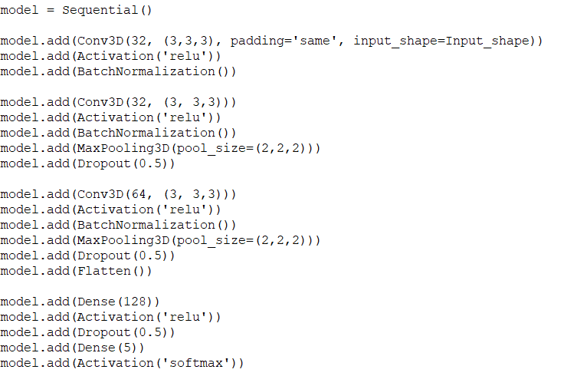  
**Result:**- Model is under-fitting as both training and validation accuracy are poor.- There are abrupt spikes in the accuracy, indicating unstable nature of the model.  
**Exp. 2 : Changing Activation Function**Next, we updated activation function ‘elu’ keeping rest same.  
**Result:**  
- Model performance is almost similar after changing the activation function.  
- Model is under-fitting as both training and validation accuracy are poor.  
**Exp. 3 : Changing Kernel Size**Next, changing the kernel size from (3,3,3) to (2,2,2) **Result:**- No improvement in model performance.- Model is under-fitting as both training and validation accuracy are poor.  
**Exp. 4 : Changing Batch Size**Next, changing the batch size from 64 to 70 **Result:**  Got ResourceExhaustedError. This means we cannot experiment with batch sizes larger than 64.  
**Exp. 5 : Changing Input Frame and Normalization**- Instead of taking all consecutive frames from last half of video, taking alternative frames throughout the video as input to the network.- Used mean subtraction as normalizing technique for the batch. (similar to VGG_ILSVRC_16_layers architecture, where BGR values are subtracted with [103.939, 116.779, 123.68])- Added extra layers to the network.- Trained for 20 epochs.

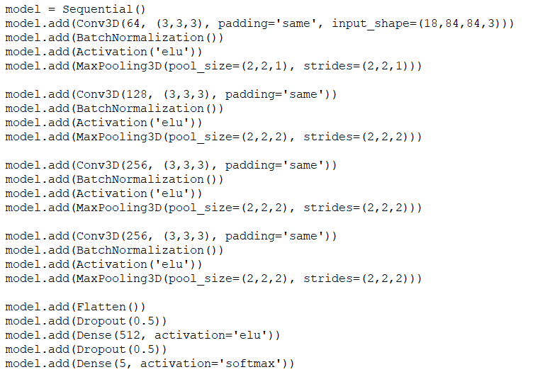  
**Result:**- Training accuracy and validation accuracy consistently improved over the epochs.  
- Low difference between train and validation accuracy and accuracy>0.60 for both confirms no over-fitting/under-fitting happening.  
- Using alternative frames helped the network to recognize gesture better.  
- Adding more layers to the previous network helped improving the performance as well.  
**Exp. 6 : Changing Momentum of learning rate**Using the same model with updated momentum (from 0.7 to 0.9).  
optimiser = optimizers.SGD(lr=0.001, decay=1e-6, momentum=0.9, nesterov=True)  
**Result:**- Training accuracy and validation accuracy consistently improved over the epochs.  
- Accuracy score was best for momentum = 0.9  
**Exp. 7 : Changing Image Size**Using the same model with (100X100) image frames  
**Result:** Performance is almost same.  
**Exp. 8 : Changing Initial Learning Rate**  
optimiser = optimizers.SGD(lr=0.0001, decay=1e-6, momentum=0.9, nesterov=True)  
Using the same model with (100X100) image frames  
**Result:** Model slightly over-fitted.  
**Exp. 9 : Using All Image Frames**  
Using the same model with all 30 frames instead of 18 alternative frames.  
**Result:** Model slightly over-fitted.  
- This will increase the input size and processing time, however not necessary to improve accuracy.  
**Exp. 10 : Conv2D+GRU base model**  
- Using the following model as base for CNN+RNN architecture  
- For each video frames from 11th to 29th index are fed to the network.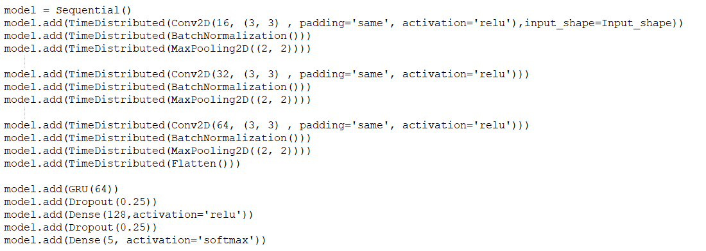- Normalization done of by diving every pixel by 255.  
- optimiser = optimizers.SGD(lr=0.001, decay=1e-6, momentum=0.7)  
**Result:** No improvement in model performance.- Model is under-fitting as both training and validation accuracy are poor.  
**Exp. 11 : Adding Layers**- Adding more layer to the previous model to improve learning. **Result:** No improvement in model performance.- Model is under-fitting as both training and validation accuracy are poor.  
**Exp. 12 : Changing Image Size**- Using (100X100) images  **Result:**- Model is under-fitting as both training and validation accuracy are poor. **Exp. 13 : Updating Momentum**- Using alternative image frame of size (84X84)- optimiser = optimizers.SGD(lr=0.001, decay=1e-6, momentum=0.9) **Result:**- Model performance improved, slightly over-fitting. **Exp. 14:**- Using alternative image frame of size (100X100)- optimiser = optimizers.SGD(lr=0.001, decay=1e-6, momentum=0.9)

**Result:**- Model performance improved, slightly over-fitting.  
**Exp. 15 : Using All Frame**- Using all 30 image frames.  
- optimiser = optimizers.SGD(lr=0.001, decay=1e-6, momentum=0.9)

**Result:**- Model performance improved, slightly over-fitting.